Exercise 1: Inventory Management System
Scenario:
You are developing an inventory management system for a warehouse. Efficient data storage and retrieval are crucial.
Steps:
- Understand the Problem:
  - Explain why data structures and algorithms are essential in handling large inventories.
Ans:
In an inventory management system, thousands of products may be stored and managed. Efficient data structures and algorithms help to:

- Store large amounts of product data efficiently.
- Quickly search for products.
- Update product information without delays.
- Delete products efficiently.
- Improve overall system performance and scalability.
Without proper data structures, operations may become slow as the inventory grows.

  - Discuss the types of data structures suitable for this problem.
Ans:
Data Structure | Advantages | Use Case
ArrayList | Easy insertion and traversal | Small inventories
LinkedList | Efficient insertion/deletion | Frequent modifications
HashMap | Fast search, update, delete | Large inventories (Recommended)
TreeMap | Sorted storage | When products need ordering

Recommended: HashMap<Integer, Product> because it provides average O(1) time complexity for add, update, and delete operations.
- Setup:
  - Create a new project for the inventory management system.
- Implementation:
  - Define a class Product with attributes like productId, productName, quantity, and price.
  - Choose an appropriate data structure to store the products (e.g., ArrayList, HashMap).
  - Implement methods to add, update, and delete products from the inventory.
- Analysis:
  - Analyze the time complexity of each operation (add, update, delete) in your chosen data structure.
  - Discuss how you can optimize these operations.
- Output:
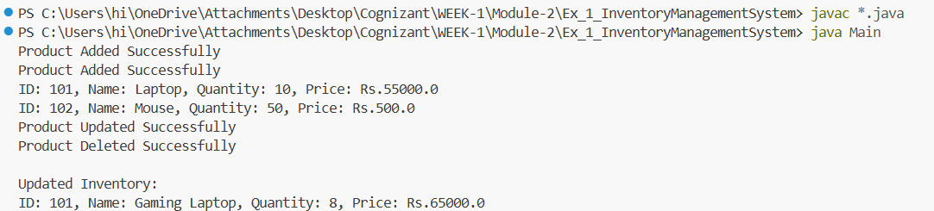

Exercise 2: E-commerce Platform Search Function
Scenario:
You are working on the search functionality of an e-commerce platform. The search needs to be optimized for fast performance.
Steps:
- Understand Asymptotic Notation:
  - Explain Big O notation and how it helps in analyzing algorithms.
Ans:
Big O Notation is a mathematical representation used to describe the efficiency of an algorithm in terms of time and space as the input size increases.

It helps in:

Measuring algorithm performance.
Comparing different algorithms.
Predicting how an algorithm will scale for large datasets.
Choosing the most efficient solution.

Examples:

O(1) → Constant Time
O(log n) → Logarithmic Time
O(n) → Linear Time
O(n²) → Quadratic Time

  - Describe the best, average, and worst-case scenarios for search operations.
Ans:
Best Case:
The element is found in the first comparison.

Linear Search: O(1)
Binary Search: O(1)

Average Case:
The element is found somewhere in the middle of the dataset.

Linear Search: O(n)
Binary Search: O(log n)

Worst Case:
The element is found at the last position or is not present in the dataset.

Linear Search: O(n)
Binary Search: O(log n)

Thus, Binary Search is generally faster than Linear Search for large sorted datasets because it reduces the search space by half in each step.

- Setup:
  - Create a class Product with attributes for searching, such as productId, productName, and category.
- Implementation:
  - Implement linear search and binary search algorithms.
  - Store products in an array for linear search and a sorted array for binary search.
- Analysis:
  - Compare the time complexity of linear and binary search algorithms.
  - Discuss which algorithm is more suitable for your platform and why.
- Output:
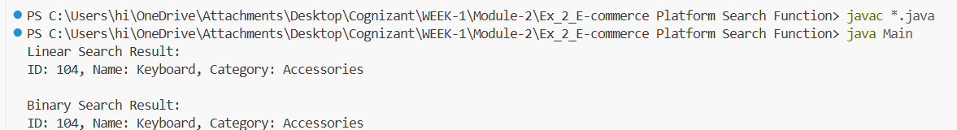

Exercise 3: Sorting Customer Orders
Scenario:
You are tasked with sorting customer orders by their total price on an e-commerce platform. This helps in prioritizing high-value orders.
Steps:
- Understand Sorting Algorithms:
  - Explain different sorting algorithms (Bubble Sort, Insertion Sort, Quick Sort, Merge Sort).
Ans:
1. Bubble Sort
Bubble Sort repeatedly compares adjacent elements and swaps them if they are in the wrong order. The process continues until the array is sorted.
Time Complexity:
Best Case: O(n)
Average Case: O(n²)
Worst Case: O(n²)
Advantage: Easy to implement.
Disadvantage: Inefficient for large datasets.

2. Insertion Sort
Insertion Sort builds a sorted array one element at a time by inserting each element into its correct position.
Time Complexity:
Best Case: O(n)
Average Case: O(n²)
Worst Case: O(n²)
Advantage: Efficient for small or nearly sorted datasets.
Disadvantage: Slow for large datasets.

3. Quick Sort
Quick Sort uses the divide-and-conquer approach. It selects a pivot element, partitions the array around the pivot, and recursively sorts the subarrays.

Time Complexity:
Best Case: O(n log n)
Average Case: O(n log n)
Worst Case: O(n²)
Advantage: Very fast and widely used in practice.
Disadvantage: Worst-case performance occurs when poor pivots are chosen.

4. Merge Sort
Merge Sort divides the array into smaller halves, recursively sorts them, and then merges the sorted halves.

Time Complexity:
Best Case: O(n log n)
Average Case: O(n log n)
Worst Case: O(n log n)

Advantage: Stable and efficient for large datasets.
Disadvantage: Requires extra memory for merging.
Conclusion:
Bubble Sort and Insertion Sort are simple but slower for large datasets, whereas Quick Sort and Merge Sort are more efficient and suitable for large-scale applications. Quick Sort is generally preferred because of its excellent average-case performance.

- Setup:
  - Create a class Order with attributes like orderId, customerName, and totalPrice.
- Implementation:
  - Implement Bubble Sort to sort orders by totalPrice.
  - Implement Quick Sort to sort orders by totalPrice.
- Analysis:
  - Compare the performance (time complexity) of Bubble Sort and Quick Sort.
  - Discuss why Quick Sort is generally preferred over Bubble Sort.

- Output:

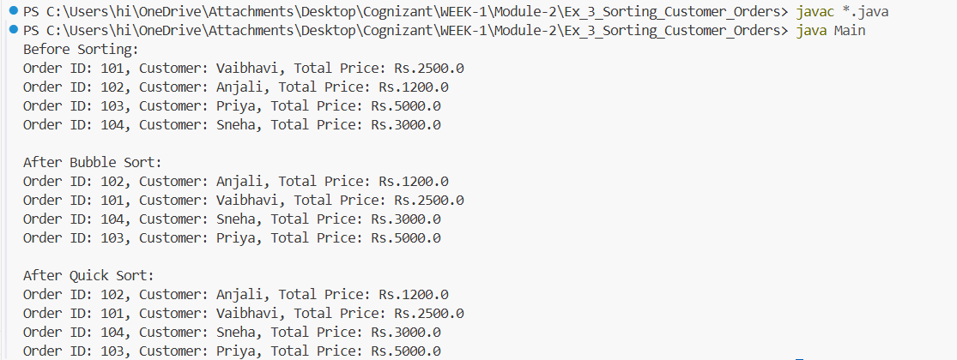

Exercise 4: Employee Management System
Scenario:
You are developing an employee management system for a company. Efficiently managing employee records is crucial.
Steps:
- Understand Array Representation:
  - Explain how arrays are represented in memory and their advantages.
Ans:
Array Representation in Memory

An array stores elements in contiguous (continuous) memory locations. Each element occupies a fixed amount of memory, and the address of any element can be calculated using its index.

Formula:
Address of Element = Base Address + (Index × Size of Element)

Example:
Employee Array
Index: 0 1 2 3
Data : [E1] [E2] [E3] [E4]

Memory:
1000 1004 1008 1012
Here, all elements are stored in consecutive memory locations.
Advantages of Arrays
    - Fast Access
    - Elements can be accessed directly using their index.

Time Complexity: O(1)
- Easy Traversal
- Elements can be processed sequentially using loops.
- Memory Efficient
- Arrays do not require extra memory for pointers or links.
- Simple Implementation
- Easy to create, store, and manage dataSuitable for Fixed-Size Data
- Ideal when the number of elements is known beforehand.
Conclusion
Arrays store elements in contiguous memory locations, enabling fast access and efficient traversal. They are simple, memory-efficient, and suitable for applications where the number of records is fixed or known in advance.

- Setup:
  - Create a class Employee with attributes like employeeId, name, position, and salary.
- Implementation:
  - Use an array to store employee records.
  - Implement methods to add, search, traverse, and delete employees in the array.
- Analysis:
  - Analyze the time complexity of each operation (add, search, traverse, delete).
  - Discuss the limitations of arrays and when to use them.
- Output:
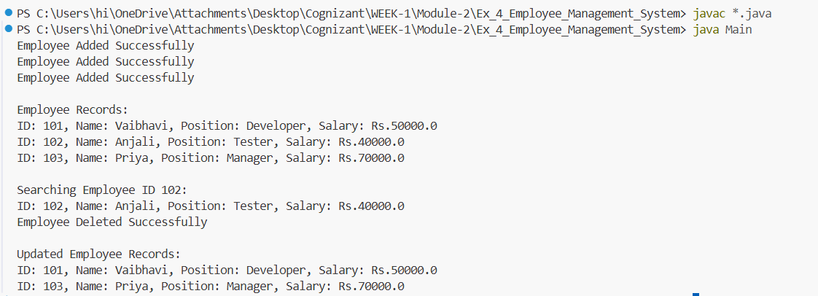

Exercise 5: Task Management System
Scenario:
You are developing a task management system where tasks need to be added, deleted, and traversed efficiently.
Steps:
- Understand Linked Lists:
  - Explain the different types of linked lists (Singly Linked List, Doubly Linked List).
Ans:
1. Singly Linked List
A Singly Linked List is a collection of nodes where each node contains:
Data
A reference (pointer) to the next node
Traversal is possible only in the forward direction.
Representation:
Head → [Data|Next] → [Data|Next] → [Data|Next] → NULL
Advantages:
Requires less memory.
Easy to implement.
Efficient insertion and deletion at the beginning.
Disadvantages:
Traversal is only forward.
Cannot move backward through the list.
2. Doubly Linked List
A Doubly Linked List is a collection of nodes where each node contains:
Data
Reference to the previous node
Reference to the next node
Traversal is possible in both forward and backward directions.
Representation:
NULL ← [Prev|Data|Next] ⇄ [Prev|Data|Next] ⇄ [Prev|Data|Next] → NULL
Advantages:
Supports bidirectional traversal.
Easier deletion and insertion at any position.
Disadvantages:
Requires extra memory for the previous pointer.
More complex implementation.
Conclusion
Singly Linked List: Uses one pointer (next) and allows traversal only in the forward direction.
Doubly Linked List: Uses two pointers (previous and next) and allows traversal in both forward and backward directions.
For the Task Management System, a Singly Linked List is sufficient because tasks can be added, searched, traversed, and deleted efficiently while using less memory.
- Setup:
  - Create a class Task with attributes like taskId, taskName, and status.
- Implementation:
  - Implement a singly linked list to manage tasks.
  - Implement methods to add, search, traverse, and delete tasks in the linked list.
- Analysis:
  - Analyze the time complexity of each operation.
  - Discuss the advantages of linked lists over arrays for dynamic data.

- Output:

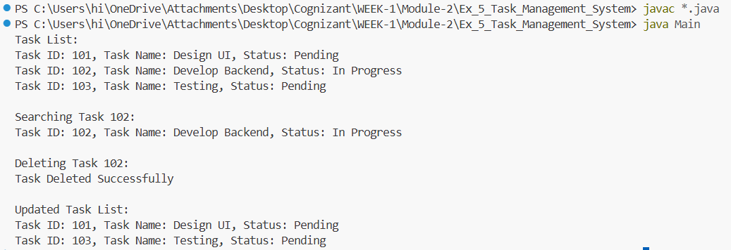

Exercise 6: Library Management System
Scenario:
You are developing a library management system where users can search for books by title or author.
Steps:
- Understand Search Algorithms:
  - Explain linear search and binary search algorithms.
- Setup:
  - Create a class Book with attributes like bookId, title, and author.
- Implementation:
  - Implement linear search to find books by title.
  - Implement binary search to find books by title (assuming the list is sorted).
- Analysis:
  - Compare the time complexity of linear and binary search
  - Discuss when to use each algorithm based on the data set size and order.

- Output:

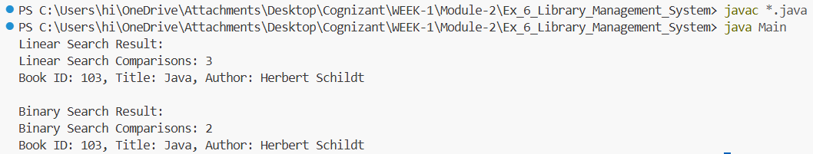

Exercise 7: Financial Forecasting
Scenario:
You are developing a financial forecasting tool that predicts future values based on past data.
Steps:
- Understand Recursive Algorithms:
  - Explain the concept of recursion and how it can simplify certain problems.
Ans:
Recursion is a programming technique in which a function calls itself to solve a problem by breaking it into smaller, similar subproblems. A recursive function must have a base case to stop the recursion and prevent infinite calls.
Components of Recursion
Base Case: Condition that stops the recursion.
Recursive Case: Function calls itself with a smaller input.
Example
factorial(n) = n * factorial(n - 1)
For:
factorial(5)
= 5 × factorial(4)
= 5 × 4 × factorial(3)
= 5 × 4 × 3 × factorial(2)
= 5 × 4 × 3 × 2 × factorial(1)
= 120
Advantages of Recursion
Simplifies complex problems by breaking them into smaller subproblems.
Makes code shorter and easier to understand.
Useful for problems involving trees, graphs, divide-and-conquer algorithms, and mathematical calculations.
Applications of Recursion
Factorial calculation
Fibonacci series
Binary Search
Tree Traversal
Financial Forecasting
Conclusion
Recursion simplifies problem-solving by allowing a function to repeatedly call itself on smaller inputs until a base case is reached. It is especially useful for problems that can be divided into similar subproblems.
- Setup:
  - Create a method to calculate the future value using a recursive approach.
- Implementation:
  - Implement a recursive algorithm to predict future values based on past growth rates.
- Analysis:
  - Discuss the time complexity of your recursive algorithm.
  - Explain how to optimize the recursive solution to avoid excessive computation.

- Output:

